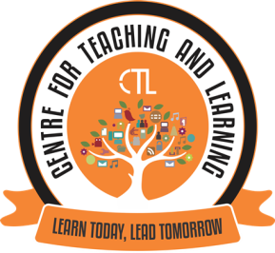

The Centre for Teaching Learning (CTL) organised the Expert FDP webinar series V on the topic “Fundamentals of Online Learning Engagement” on 25th January, 2021 for the college teaching faculty.
Mrs. Rosemaliza Mohd. Kamalludeen (Ph.D), Assistant Professor, Department of Instructional Technology, Kulliyyah of Education, IIUM, Malaysia was the speaker for this FDP.
This FDP focussed on how to engage in online teaching. Various teaching tools were also briefly introduced. She also spoke about how online assessment can be carried out and gave ideas and tips for smooth functioning of online learning. The FDP webinar Series V was attended by around 21 college faculty.

Expert Webinar FDP Series - V Photographs
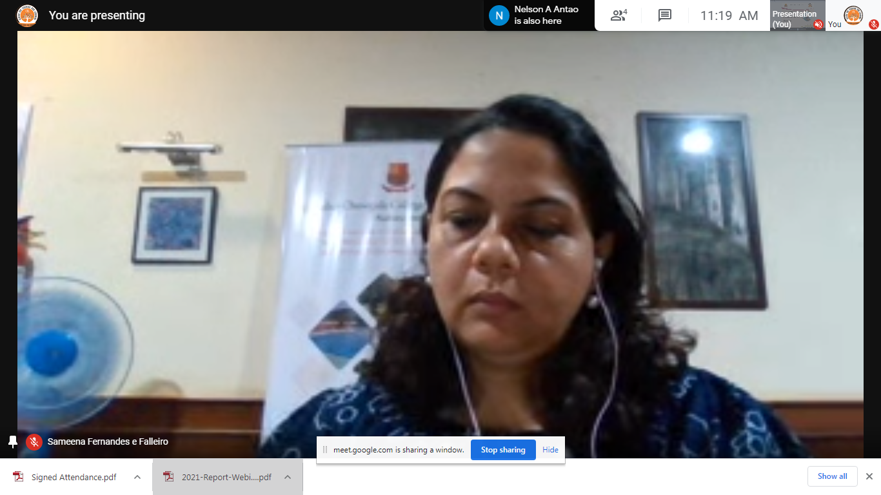
Dr Sameena Falleiro, Coordinator CTL introducing the speaker of the webinar to all the participants

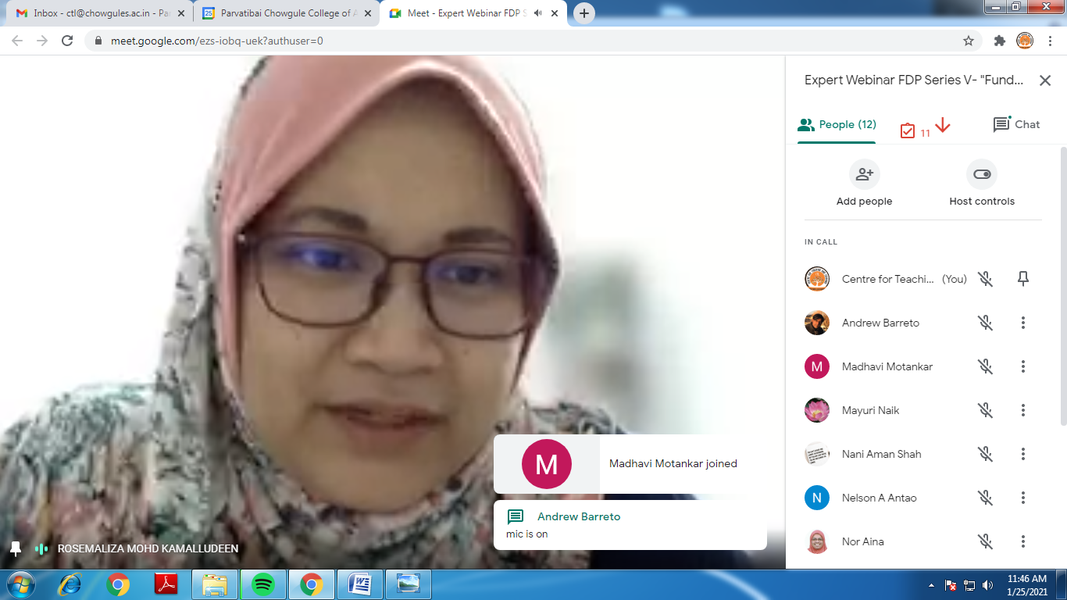
Mrs Rosemaliza Mohd. Kamalludeen (Ph.D) was the speaker for the Expert webinar FDP series - V

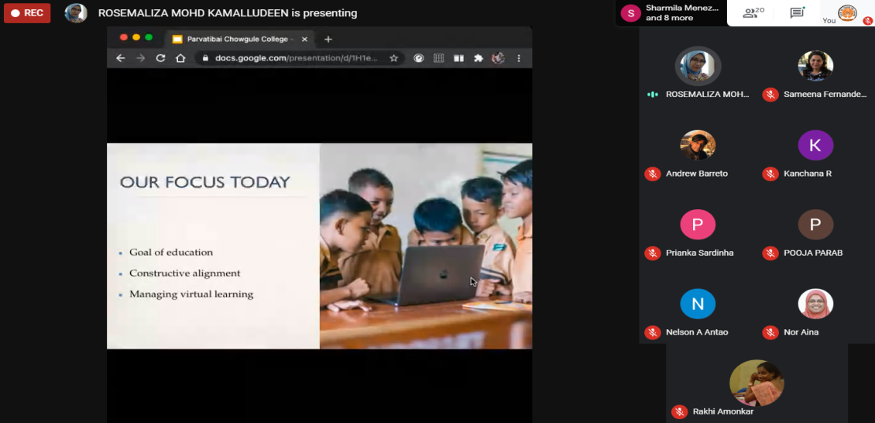
The Speaker delivering the session on the topic “Fundamentals of Online learning engagement”

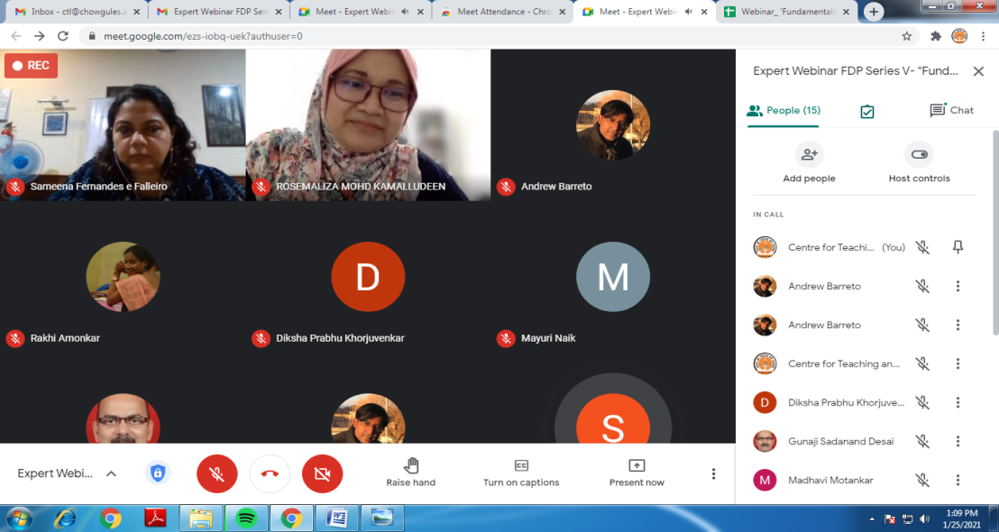
The resource person answering to all the queries of the college faculty

